- Tên và phân loại:

- Mục đích, ý nghĩa:
- Represent an operation to be performed on the elements of an
object structure
- Lets you define a new operation without changing the classes of the
elements on which it operates
- Động lực sử dụng:
- Consider a compiler that parses a program and represents the
parsed program as an abstract syntax tree (AST). The AST has many
different kinds of nodes, such as Assignment , Variable Reference,
and Arithmetic Expression nodes
- Operations that one would like to perform on the AST include:
• Checking that all variables are defined
• Checking for variables being assigned before they are used
• Type checking
• Code generation
• Pretty printing/formatting
- Encapsulate a desired operation in a separate object, called
a visitor
- The visitor object then traverses the elements of the tree
- When an tree node "accepts" the visitor, it invokes a method
on the visitor that includes the node type as an argument
- The visitor will then execute the operation for that node – the
operation that used to be in the node class
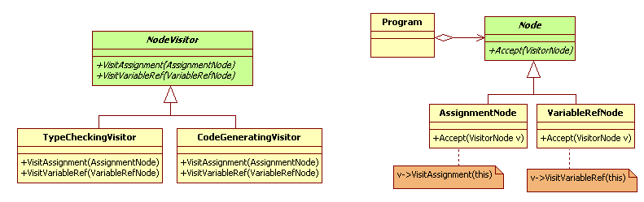
- Khi nào sử dụng:
- An object structure contains many classes of objects with
differing interfaces, and you want to perform operations on
these objects that depend on their concrete classes
- Many distinct and unrelated operations need to be performed
on objects in an object structure, and you want to avoid
"polluting" their classes with these operations
• Lets you keep related operations together by defining them in one
class
• When the object structure is shared by many applications, use
Visitor to put operations in just those applications that need them
- The classes defining the object structure rarely change, but you
often want to define new operations over the structure
• Changing the object structure classes requires redefining the
interface to all visitors, which is potentially costly
• If the object structure classes change often, then it's probably
better to define the operations in those classes

- Cấu trúc
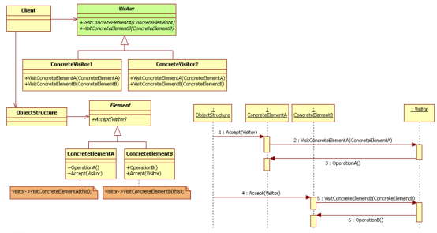
- Các thành viên - Sự cộng tác
- Visitor
• Declares a Visit operation for each class of ConcreteElement in the object
structure
• The operation's name and signature identifies the class that
- Sends the Visit request to the visitor
- Lets the visitor determine the concrete class of the element being visited
- Then the visitor can access the element directly through its particular interface
- ConcreteVisitor
• Implements each operation declared by Visitor
• Each operation implements a fragment of the algorithm defined for the
corresponding class of object in the structure
• Provides the context for the algorithm and stores its local state. This state
often accumulates results during the traversal of the structure
- Element: defines an Accept operation that takes a visitor as an
argument
- ConcreteElement: implements an Accept operation that takes a
visitor as an argument
- ObjectStructure
• Can enumerate its elements
• May provide a high-level interface to allow the visitor to visit its elements
• May either be a composite or a collection such as a list or a set
- Các hệ quả mang lại:
- Makes adding new operations easy
• Visitors make it easy to add operations that depend on the
components of complex objects. You can define a new
operation over an object structure simply by adding a new visitor
• In contrast, if you spread functionality over many classes, then
you must change each class to define a new operation
- Gathers related operations and separates unrelated ones
• Related behavior isn't spread over the classes defining the object
structure; it's localized in a visitor
• Unrelated sets of behavior are partitioned in their own visitor
subclasses
• Simplifies both the classes defining the elements and the
algorithms defined in the visitors
• Any algorithm-specific data structures can be hidden in the visitor
- Adding new ConcreteElement classes is hard
• Makes it‟s hard to add new subclasses of Element. Each new
ConcreteElement gives rise to a new abstract operation on Visitor and a
corresponding implementation in every ConcreteVisitor class
• Sometimes a default implementation can be provided in Visitor that can
be inherited by most of the ConcreteVisitors, but this is the exception
rather than the rule
- Accumulating state
• Can accumulate state as they visit each element in the object structure.
Without a visitor, this state would be passed as extra arguments to the
operations that perform the traversal, or they might appear as global
variables
- Breaking encapsulation
• Visitor's approach assumes that the ConcreteElement interface is powerful
enough to let visitors do their job
• As a result, the pattern often forces you to provide public operations that
access an element's internal state, which may compromise its
encapsulation
- Chú ý liên quan đến cài đặt:

- Hệ thống thực tế

- Mẫu liên quan
- Composite: Visitors can be used to apply an operation over an
object structure defined by the Composite pattern
- Interpreter: Visitor may be applied to do the interpretation

